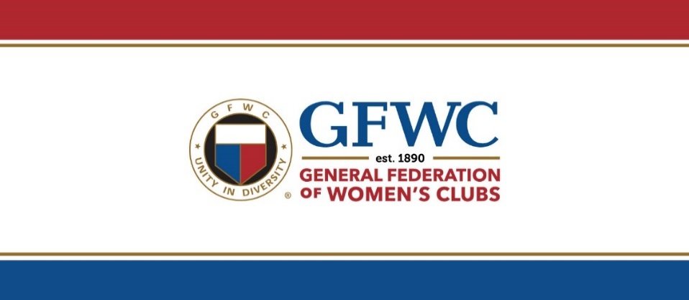
GFWC/IOWA FEDERATION OF WOMEN’S CLUBS
3839 Merle Hay Road - Suite 201
Des Moines, IA 50310
gfwciowa@qwestoffice.net (515) 276-0510

GFWC/IOWA SUMMER MUSIC CAMPSHIP APPLICATION FORM
Campships in an amount up to $400 may be used for tuition and room and board for camps within Iowa.
Preference is given to first time campship recipients. Application Deadline February 1, 2025

Applicant’s Name:
Mailing Address:
Email Address: |  | Phone # (with area code):
Name of Parent or Guardian:
Age: | Year in School:
Students Entering 8-12 grades - (Students that have completed the 7th grade)

Music Experience (specify type of experience and number of years):

Name of music camp applicant plans to attend, if known (must be in Iowa):

(Confirmation of registration is not required currently.) If known, please include the following:
Dates of Camp: | Cost: | Registration Deadline:

Applications must be accompanied by the following letters:
- Letter of recommendation from a music teacher (public school or private lessons)
- A personal letter from the applicant telling something about herself/himself, the reason for her/his application, musical ambitions, and any other pertinent information you may want to include.
******************************************************************************
STATEMENT OF INTENT:
If I am awarded a music campship from GFWC/Iowa Federation of Women’s Clubs and am unable to attend the camp of my choice, I will notify GFWC/Iowa Headquarters so that an alternate may attend and will refund any money received from GFWC/Iowa.

Signature of Applicant:

Signature of Parent or Guardian:

Email completed application with two accompanying letters to the following Scholarship Chairman:
Name of Scholarship Chairman: Bette Kuboushek
Email Address: gfwciaschol@gmail.com | Phone: 563-599-4312

